Real Time Visual Tracing AI Robotic Face

Corresponding Author: Kashif Ahmed Siddiqui¹
B.E (ECE), Muffakham Jah College of Engineering and Technology, siddiquikashif951@gmail.com, https://orcid.org/0009-0009-9031-3724, India
Co-Author: Abdul Rahman Owaise²
B.E (ECE), Muffakham Jah College of Engineering and Technology, arowaise@gmail.com, India
Guide: Mohammed Noorullah Khan³
B.E (ECE), MTech (VLSI &ES), Ph.D. (ECE), Muffakham Jah College of Engineering and Technology, noorullah.khan@mjcollege.ac.in, India

Recent progress in artificial intelligence has made it easier for machines to communicate with humans in a more natural and effective way. This project introduces a robotic face that focuses on spoken interaction without relying on facial expressions or gestures. It uses natural language processing to interpret speech and speech synthesis to respond clearly and conversationally. Designed to be open-source and budget-friendly, the system is intended for use in areas like education, assistive tools, and research into AI-human interaction. By making such technology more accessible and customizable, this work supports the broader goal of advancing conversational AI systems.

CSSConcepts •Computing methodologies~Artificial intelligence~Computer vision~Computer vision problems~Object detection•Computing methodologies~Artificial intelligence~Computer vision~Computer vision problems~Tracking•Computing methodologies~Artificial intelligence~Computer vision~Computer vision problems~Object recognition•Computing methodologies~Artificial intelligence~Natural language processing~Information extraction•General and reference~Cross-computing tools and techniques~Performance•Computer systems organization~Embedded and cyber-physical systems~Robotics•Computing methodologies~Artificial intelligence~Natural language processing~Speech recognition

Additional Keywords and Phrases Facial actuation system, Jaw–Lip synchronization, Low-cost humanoid robotics, Raspberry Pi–based robot, Real-time speech interaction, large language model integration, Eye blink simulation

1 Introduction

Robotics has seen significant growth in recent years, allowing machines to handle more complex tasks and interact with people in increasingly sophisticated ways. While some humanoid robots aim to mimic human facial expressions, others are designed with a focus on functionality—prioritizing motion, interaction, and AI-based communication rather than emotional expression. These practical robots are widely adopted in fields such as education, research, and collaborative human-machine environments.

A specific group within this functional design approach is AI-powered robotic faces. These systems concentrate on fundamental actions like tracking eye movement and syncing speech with mouth motion, rather than simulating emotions. They are especially useful in areas like educational tools, automated services, and AI system testing, where expressiveness is less important than reliable, responsive interaction.

One of the biggest obstacles in this space is accessibility. Many advanced robotic platforms are locked behind proprietary systems, limiting the ability of independent developers and researchers to experiment or tailor the technology. While leading institutions like Hanson Robotics and Hiroshi Ishiguro Laboratories have built highly realistic humanoid robots, their closed-source designs hinder broader adoption and innovation. This means that anyone looking to build similar interactive AI systems often has to start from scratch—a process that can be both expensive and time-consuming.

This project aims to overcome that barrier by offering a cost-effective, open-source robotic face designed for developers, educators, and researchers. Instead of simulating complex emotional expressions, it focuses on essential interactive functions like eye movement, jaw motion, and voice-based communication. The system is built around accessible hardware components: servo motors for motion, a Raspberry Pi 3B+ for processing, an Arduino Mega to control the servos, and an OV5647 camera for basic vision tasks. It also integrates OpenAI's API for intelligent voice responses. The physical structure is 3D-printed using PLA, making it affordable and easy to customize.

Compared to existing commercial humanoids, this design is flexible, low-cost, and suitable for a wide range of use cases. While it doesn't attempt to mimic emotions, it supports important capabilities such as gaze control and voice interaction, making it a valuable tool for further development in conversational AI. Its open-source nature makes it particularly useful for research, education, and assistive applications where customization and scalability are key.

Here are some previously developed AI-powered robotic faces similar to our project, along with their actuators, weight, head size, and cost estimates:

Table 1.1: Previously Developed AI-Powered Robotic Face
Model | Image | No. of Actuators | Weight | Head Size | Cost Estimate
Kismet (MIT, 1999) | 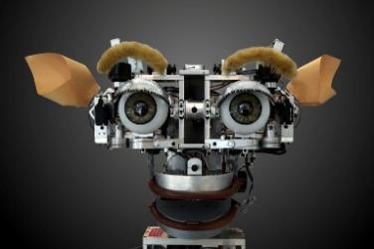 | 21 servo motors | ~4.5 kg | Approx. human head size | ~$25,000
Nexi (MIT, 2008) | 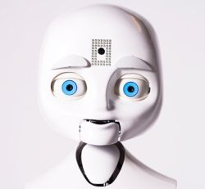 | 19 actuators | ~6.5 kg | Slightly larger than human head | ~$50,000
RoboThespian (Engineered Arts, 2005-Present) | 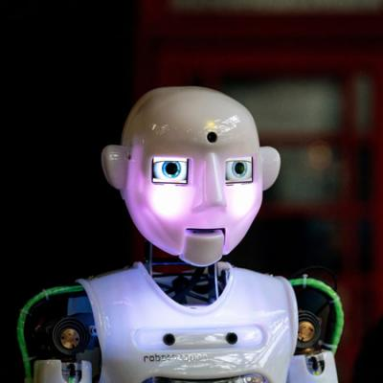 | 30+ actuators | 28 kg (full body) | Human-sized head | ~$79,000
Eva (Automata, 2021) | 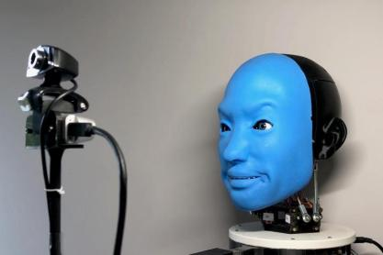 | 6 servo motors | ~2 kg | Compact robotic head | ~$8,000
Affetto (Osaka University, 2018) | 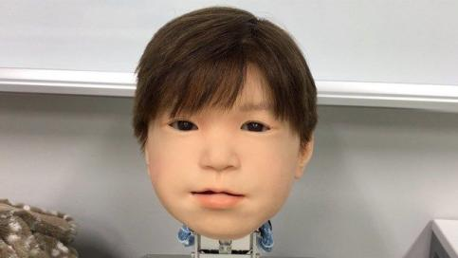 | 20+ actuators | ~4 kg | Human-like head | ~$10,000
Little Sophia (Hanson Robotics, 2020) | 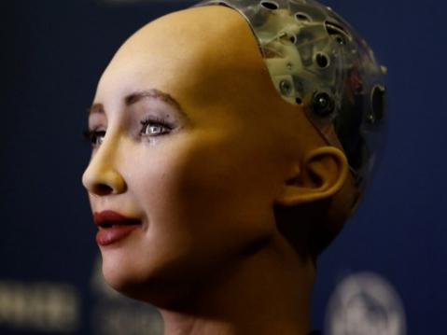 | 5 servo motors | ~1.2 kg | Miniature humanoid head | ~$250
Professor Einstein (Hanson Robotics, 2017) | 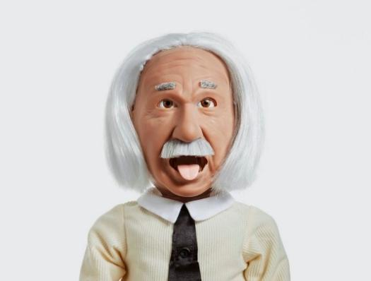 | 5 servo motors | ~2 kg | Small humanoid head | ~$300

2. Hardware Description

2.1 Overview of Hardware Components
The AI-based robotic face consists of several key mechanisms: the eye movement system, jaw actuation, and voice-assisted communication. Essential auxiliary components include the 3D-printed skull and face structure, Raspberry Pi 4 with servo drivers, power supply, cooling fan, and wiring connections. These elements work together to ensure smooth operation and effective interaction.

2.2 Eye Mechanism
The eye mechanism consists of six SG90 servo motors, responsible for controlling eyeball movement and eyelid motion. The system includes 3D-printed eyeball housings, acrylic mounting plates, and threaded rods for precise control. The OV5647 Pi camera module is used for eye tracking and basic facial recognition, allowing the robotic face to follow movements and engage in interactive responses.

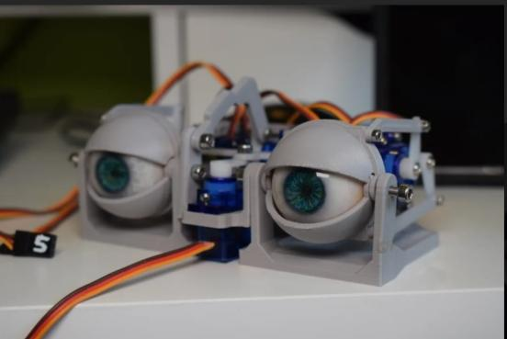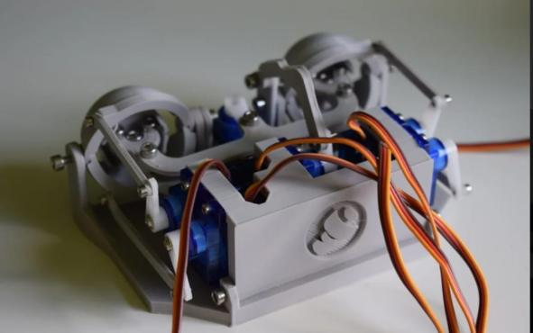

Fig.1 Eye mechanism fully assembled Fig.2 Back view of the design
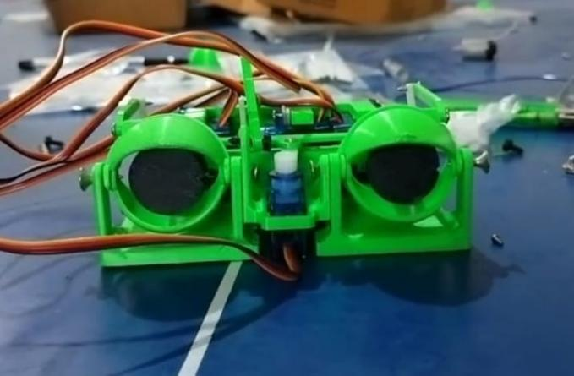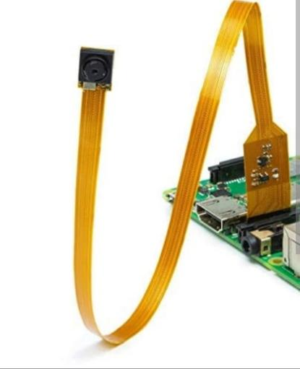
Fig.3 Eye mechanism used in the project Fig.4 Camera Module(OV5647)

2.3 Jaw Mechanism
The robotic face utilizes two MG996R servo motors for jaw actuation. These motors are mounted inside the 3D-printed skull and connected to the jaw via servo horns and linkages. When activated, the servos move the jaw in synchronization with AI-generated speech, creating the illusion of talking

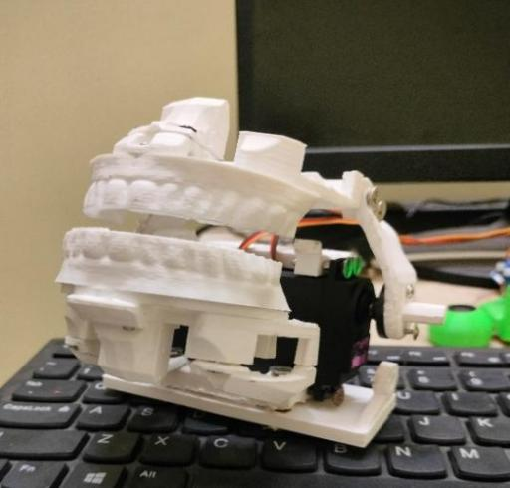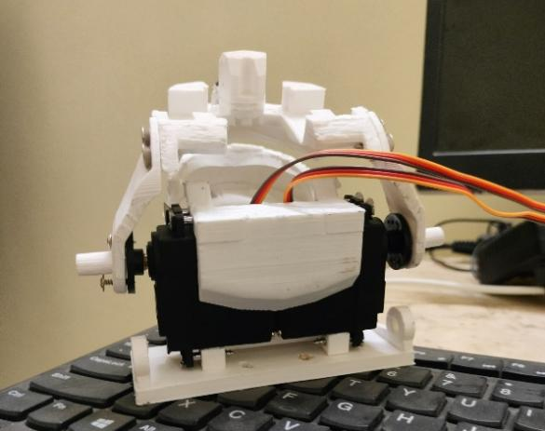
Fig.5 Jaw mechanism which moves Fig 6 Alternate angle for the jaw mechanism in sync with AI speech

2.4 Control System
The Raspberry Pi 4 serves as the central processing unit, handling AI-driven interactions and vision-based tracking. A 16-channel PWM servo driver expands the Raspberry Pi’s capability, allowing it to manage multiple servos simultaneously.

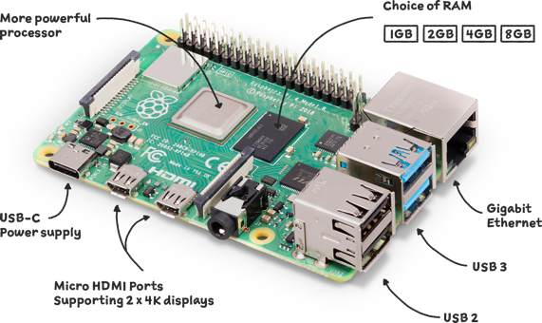
Fig.8 Raspberry Pi 5

2.5 Power and Cooling System
The system is powered by a 5V 10A power supply, providing adequate current for the servo motors and onboard electronics. A dedicated Raspberry Pi power adapter ensures stable operation of the main processing unit. Additionally, a heat sink fan is attached to the Raspberry Pi to prevent overheating and maintain performance during extended use.

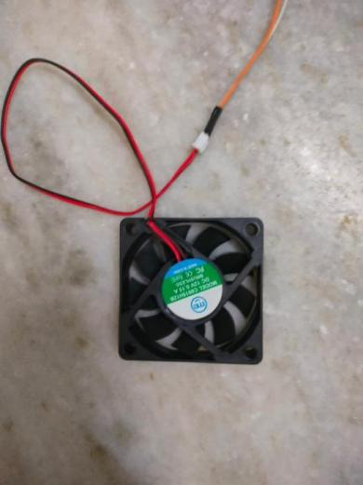
Fig 9: Heat Sink

2.6 Structural Components
The entire robotic face is housed within a 3D-printed skull and jaw structure, fabricated using PLA material for durability and lightweight performance. The skull provides mounting points for servos and electronic components, ensuring stability and ease of assembly. Connecting wires, screws, and mounting brackets complete the assembly, securing all hardware elements in place.

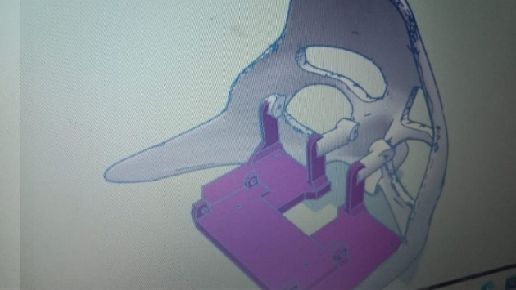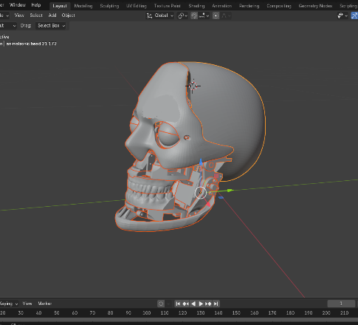
Fig.10 Face mechanism merged with eye mechanism Fig.11 Face assembled model

3. Utility for Researchers
This AI-powered robotic face is designed to be affordable, flexible, and easily customizable, making it a valuable tool for researchers. Its benefits can be summarized in the following key points:

Cost-Effective and Easy to Build: Unlike proprietary humanoid robots that are expensive and complex to modify, this robotic face is designed to be affordable and easy to assemble using common components and open-source technologies. Researchers can build on its existing framework without needing to start from scratch.

Ideal for Long-Term Research: Many commercial humanoid robots are only available for short-term use or come with licensing restrictions, making them impractical for extended academic research. This open-source robotic face provides a stable, long-term research platform for AI and robotics studies.

Versatile Programming Options: Supporting multiple programming languages, including Python, this robotic face runs on open-source platforms like Raspberry Pi. Unlike commercial robots that depend on proprietary software, researchers have full control over customization and feature expansion.

Modular and Customizable: The modular hardware design allows researchers to modify and enhance various aspects, including servo control, AI algorithms, and mechanical components. Any improvements can be documented and shared, benefiting the wider research community.

4. Bill of Materials

Below is a detailed list of components required to build the AI-powered robotic face, along with their estimated costs:
Table 4: Rough Estimate of materials
Component | Quantity | Estimated Cost (INR)
Raspberry Pi 5 | 1 | 6,500
SG90 Servo Motors | 6 | 1,550
MG996R Servo Motors | 2 | 1,000
OV5647 Pi Camera Module | 1 | 3,450
16-Channel PWM Servo Driver | 1 | 400
5V 10A Power Supply | 1 | 400
Raspberry Pi Power Adapter | 1 | 800
Heat Sink Fan for Raspberry Pi | 1 | 300
3D Printing Material (PLA) | - | 10,000
Connecting Wires | - | 1,000
M3, M4, M5 Metric Screws | - | 1,500
Miscellaneous Components | - | 1,200
Wooden Placeholder for the face | - | 1,500
Total Estimated Cost | - | 29,600/-

5. Build Instructions

5.1 Construction of Components
The robotic face follows a modular design, meaning that individual components can be built separately and then assembled. The key components include:

Eye Mechanism: Composed of six SG90 servo motors for eye movement and eyelid control, 3D-printed eyeball housings, and an OV5647 Pi camera for eye tracking and facial recognition.

Jaw Mechanism: Two MG996R servo motors control jaw movement, enabling synchronized motion with AI-driven speech.

3D-Printed Skull and Facial Structure: Provides mounting points for all electronic and mechanical components.

Control System: A Raspberry Pi 4 as the central processor, an Arduino Mega for servo management, and a 16-channel PWM driver for motor control.

Power System: Includes a 5V 10A power supply, a Raspberry Pi power adapter, and a heat sink fan for cooling.
Each component must be carefully 3D printed, assembled, and tested before final integration.

5.2 Assembly of Components
The assembly process should follow a structured sequence to ensure smooth integration:
Assembling the Skull and Frame:
Start by securing the 3D-printed skull and jaw structure.
Ensure that all attachment points align correctly for servos and electronics.

Installing the Eye Mechanism:
Mount the eyeballs and eyelids in their designated positions and connect the servo motors for movement control.

Integrating the Jaw Mechanism: Secure the jaw structure and install the MG996R servos, ensuring they move fluidly for speech synchronization.

Connecting the Electronics: Attach the Raspberry Pi, Arduino Mega, and PWM driver, making sure all wires are properly routed and secured.
Final Wiring and Power Setup: Connect the power supply, cooling fan, and control board to complete the circuit.
After assembly, thorough testing of servo movement, eye tracking, and AI voice interaction is necessary before full deployment.

5.3 Potential Hazards and Safety Considerations
Building this robotic face requires working with 3D-printed components, servos, and electronic wiring. While most assembly steps are straightforward, keep in mind the following safety guidelines:
Handle electronic components with care to avoid static discharge or accidental damage.
Avoid overloading servos to prevent overheating and ensure smooth movement.
Properly secure wiring to avoid loose connections or short circuits.
Test AI interactions in a controlled environment before full integration.

- Operation Instructions

6.1 Operating Procedure

Operating this robotic face is straightforward. Follow these steps for a smooth experience:

Setting Up the Robotic Face:
-Place the robotic face on a stable, flat surface to prevent unnecessary movement.
-Ensure that all components, including servo motors, Raspberry Pi, Arduino Mega, and wiring, are correctly secured.

Connecting External Devices:
-Plug in an HDMI monitor to the Raspberry Pi for an easy interface.
-Connect a keyboard and mouse via USB for direct control and programming.

Powering the System:
-Plug in the Raspberry Pi power adapter and turn it on.
-Allow the system to boot and access the desktop interface.
-Connect to a Wi-Fi network if an internet connection is needed.

Programming the Robot:
-Open a coding environment like Python (recommended).
-Load or write the script for eye tracking, jaw movement, and AI-driven speech.
-Before executing the program, connect the 5V 10A power supply to enable servo motor operation.

Running and Testing the Robot:
-Run the script and observe as the robotic face tracks movement, opens/closes its jaw, and responds using AI speech.
-Adjust parameters as needed to fine-tune performance.

Shutting Down Properly:
-Stop any running scripts and disconnect the 5V 10A power supply.
-Power down the Raspberry Pi safely and unplug all external devices.
-Store the robotic face in a safe, dust-free area when not in use.

6.2 Safety Guidelines
To ensure smooth operation and protect the components, keep these safety measures in mind:

Prevent Overheating:
-Avoid continuous operation of servo motors for long periods, as they may overheat.
-Make sure the heat sink fan on the Raspberry Pi is running correctly.
-Operate the system in a cool, ventilated room, preferably with air conditioning.

Use the Correct Power Supply:
-Stick to the approved power sources listed in the Bill of Materials.
-Avoid using higher voltage power supplies, as they may damage the Raspberry Pi and servos.
-Double-check wiring to prevent short circuits or electrical failures.

Handle Components with Care:
-Be gentle when moving the robotic face to prevent damage to servo motors and wiring.
-Keep objects away from moving parts to avoid obstruction and mechanical failure.
-Store the robot securely when not in use to protect it from dust and accidental damage.

7. Validation and Characterization

7.1 Demonstration of Functionality

The robotic face has been tested to ensure that all its key functions are working as expected. The system successfully demonstrates eye tracking, blinking, jaw movement, and AI-powered voice responses. The servos control the eyeballs and eyelids with precision, allowing smooth transitions between open and closed states, as well as directional gaze shifts. The jaw mechanism moves in sync with speech output, making the interaction feel more natural.
For a more detailed demonstration, a recorded test session is available. The video showcases how the robotic face responds to different input commands, tracks objects with its eyes, and articulates its jaw in coordination with speech.

Limitations and Future Improvements
While the robotic face performs well in its current state, there are areas where improvements can be made:

Limited Sensory Input:
At present, the system primarily relies on the camera module for interaction. Incorporating a microphone would allow it to respond to voice commands, making interactions more dynamic.
Future updates could include emotion recognition software, enabling the robotic face to adapt its responses based on detected human emotions.

Jaw Movement Constraints:
The jaw has a limited range of motion, mainly due to the rigidity of the 3D-printed structure.
This can be improved by using more powerful servo motors or redesigning the jaw mechanism to allow greater flexibility.

Servo Motor Noise:
-The current servo motors produce noticeable noise, which may be distracting in a quiet environment.
-Replacing them with quieter, high-quality servos or adding sound-dampening components could help mitigate this issue.

Heat Management:
-Extended use may lead to overheating, especially in warm environments with little airflow.
-Adding more ventilation holes in the 3D-printed skull or installing additional cooling fans could improve thermal management.

Software Refinements:
-The synchronization between jaw movement and speech could be further refined for better accuracy.
-Implementing smoother motion transitions in servo control logic could make interactions feel more lifelike.

7.3 Performance Metrics
The following key metrics were recorded to evaluate the robotic face’s performance:

-Power Consumption: The total power draw of the system, including the servos and cooling fan, ranges between 7.65A and 9.17A during normal operation. The 5V 10A power supply is sufficient to maintain stable performance.

-Continuous Operation: The robotic face was tested for 3 hours of continuous use in a controlled environment. It operated consistently without significant overheating issues.

-Range of Motion:
Eyeballs: Horizontal and vertical range of approximately 45 degrees.
Eyelids: Fully operable, with a 70-degree range of motion.
Jaw: The current movement range is 15 degrees, which may require future improvements for better articulation.

Code: The code for the project can be accessed from the following link:
https://github.com/kashifff7/Real-Time-Visual-Tracing-AI-Robotic-Face

Declaration of Competing Interest:
The authors declare that they have no known competing financial interests or personal relationships that could have appeared to influence the work reported in this paper.

Acknowledgments:
Thank you to Professor and the Department of for their support throughout the course of this project. This work has been supported in part by Muffakham Jah College of Engineering and Technology.

References:
Breazeal, C., Sociable Machines: Expressive Social Exchange Between Humans and Robots (Nexi, David L. Chandler, MIT,2008)
Face Detection and Tracking for Human Robot Interaction through Service Robot (Ren C. Luo; An C. Tsai; Chung T. Liao,2019)
Humanoid Robots: Use Cases as AI-Lab Companion (Manfred Langen; Sabrina Heinrich,2019)
Dobby: A Conversational Service Robot Driven by GPT-4 (Carson Stark; Bohkyung Chun; Casey Charleston; Varsha Ravi; Luis Pabon; Surya Sunkari,2024)
Real-time Face Tracking for Human-Robot Interaction (Muhamad Dwisnanto Putro; Kang-Hyun Jo,2018)
Eva: A low-cost open-source facially expressive humanoid head for emotional AI research.
HardwareX, 9, e00117. (Faraj, Z., Selamet, M., Morales, C., & Chen, B. ,2021)
Building artificial humans to understand humans. Journal of Artificial Organs, 10(3), 133–142. (Ishiguro, H., & Nishio, S. ,2007)
Development of facially expressive humanoid robotic head using servo motors.
International Journal of Robotics and Automation (IJRA), 8(2), 94–101(Saxena, R., & Kamdar, R. ,2019)

